**LAB ASSESSMENT -09**

1. Create a simple HTML document structure with a heading, a paragraph, and an image.

Text Formatting:

Apply bold and italic formatting to specific words within a paragraph.

Krishna

Krishna is the Hindu god or compassion, protection, and love. Also called the Dark One, Krishna is an important character in many Hindu sacred texts, including the Bhagavad Gila. He is portrayed in various ways in Indian mythology and child-god ra divine lover, prankster 'o hero



2. Create an ordered (numbered) and an unordered (bulleted) list.



3.Insert an image and provide appropriate alt text.

Style the image with CSS to control its size.

**Beautiful Landscape**



4.Explain the CSS box model and its components (margin, border, padding, content).

Adjust the width, height, margin, padding, and border of an element.

CSS Box Model

|  |  |
| --- | --- |
| Thix n | box whith |

5. Create a simple form with text fields, radio buttons, checkboxes, and a submit button.

Apply CSS styles to improve the form's appearance.

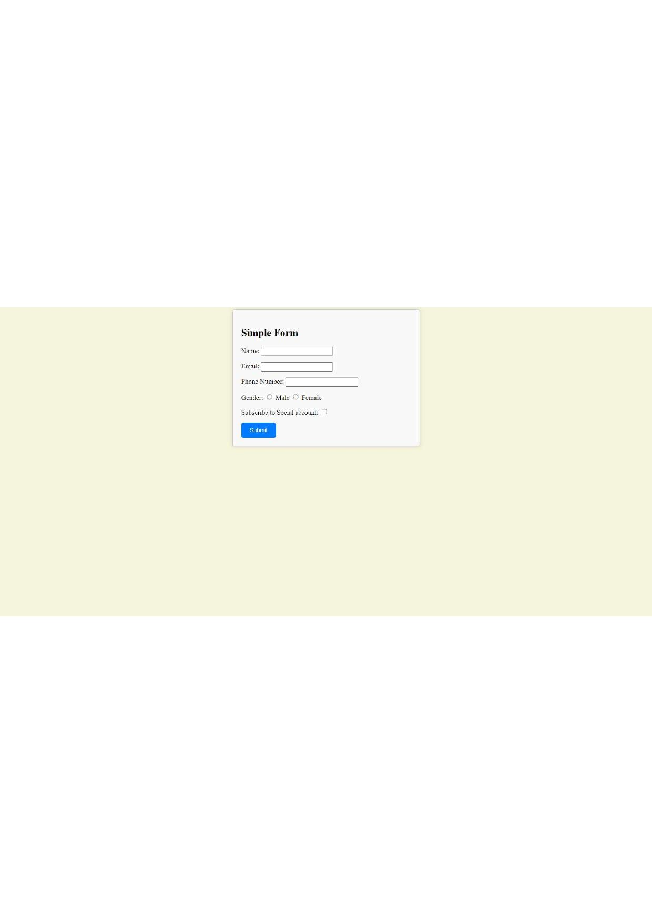

6. How do you link an external CSS stylesheet to an HTML document?

To link an external CSS stylesheet to an HTML document, you can use the < link> element within the <head> section of your HTML document. Here's how you do it:

Create your CSS stylesheet: First, create a separate CSS file with your styling rules. Save it with a .css file extension. For example, you could name it styles.css.

Link the CSS file in your HTML document: Open your HTML document and insert the following code within the <head> section:

html

Copy code html>

<html>

<head>

<tit1e>Your Page Title</title>

< link rel=" stylesheet" type="text/css" href="styles.css"> </head>

< ! -- Your HTML content goes here - >

</bodp

</html>

Explanation of the < link> element attributes:

rel="stylesheet": This attribute specifies the relationship between the HTML document and the linked resource, indicating that it's a stylesheet. type="text/css": This attribute specifies the type of the linked resource, which is a CSS stylesheet.

href=" styles . css" : This attribute specifies the path or URL of the CSS stylesheet you want to link. Adjust the value to match the actual path of your CSS file.

Make sure that the href attribute points to the correct location of your CSS file. This can be a relative or absolute path, depending on the file's location in relation to your HTML document.

Once you 've linked the external CSS stylesheet using the < link> element, the styling rules from your CSS file will be applied to the HTML content in the document.

The style attribute in HTML tags is used to apply inline CSS styles directly to individual HTML elements. It allows you to define specific styling rules for a particular element without using an external CSS stylesheet or internal < style> tags within the <head> section of the HTML document.

Here's how the style attribute works:

Inline Styling: You add the style attribute within an HTML tag and provide CSS property-value pairs. These styles apply only to the specific element that contains the style attr

7. What is the purpose of the style attribute in HTML tags?

Specificity: Inline styles have a high level of specificity, which means they override external and internal styles. However, this can lead to reduced maintainability and separation of concerns in larger projects.

Here's an example of using the style attribute:

 style="color: blue; font-size: 16px; ">This is a blue and larger text.</p>

In this example, the style attribute is applied directly to the tag. The specified styles, color: blue; and font-size: 16px;, will affect only this specific paragraph and won't be applied to other paragraphs on the page.

While the style attribute is convenient for quick inline styling, it's generally recommended to use external CSS stylesheets or internal < style> tags for larger projects to promote better organization, separation of concerns, and maintainability of your code.